

Carson Tahoe Vehicles of Change
Volunteer Internship Opportunity
Carson Tahoe’s Vehicles of Change is a mobile youth mental health prevention program delivering hands-on, skills-based education in schools and community settings serving the quad counties (Carson City, Storey, Lyon, & Douglas Counties). To respond to the youth mental health crisis, we turn evidence-based therapies into play-based activities to build resilience, coping skills, emotional literacy, and healthy peer connection.
CHW interns will gain real-world experience in:
- Community-based health education and prevention
- Youth engagement and group facilitation
- Outreach, relationship-building, and community partnership
- Program evaluation and outcome tracking within a healthcare system
This internship provides meaningful field hours while offering direct exposure to how prevention programming integrates within a hospital system — preparing students for future roles in community health, care coordination, and population health initiatives.
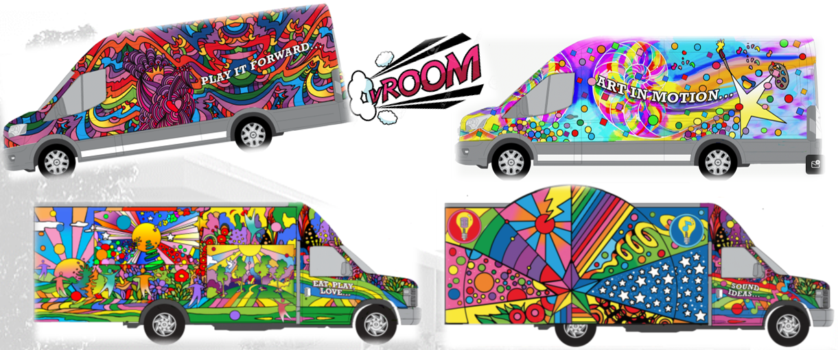

Section 1: Basic Information
- Full Name
- Contact Information (phone & email)
- Address
- Emergency Contact (name, relationship, phone)

Section 2: Availability
- Which days/times are you available to volunteer?
- How many hours per week are you interested in volunteering?

Section 3: Experience & Skills
- Have you had prior experience working with children or youth? ☐ Yes ☐ No
  - If yes, please describe your experience.
- Have you worked with diverse populations, including individuals with disabilities, behavioral health needs, or from various cultural backgrounds? ☐ Yes ☐ No
  - If yes, please describe your experience.
- Are you comfortable working in a variety of settings (virtual/classroom/outdoors) and following program protocols? ☐ Yes ☐ No
- Do you have any certifications, trainings, or special skills relevant to supporting children, families, or wellness activities?
- Are you comfortable interacting with children of all ages, including infants, toddlers, school-age children, and teens, in a virtual or in-person setting? ☐ Yes ☐ No
  - If no, please explain any limitations.
- Are you able to maintain confidentiality and follow HIPAA guidelines when supporting participants? ☐ Yes ☐ No
- Do you have any physical, emotional, or other limitations that may affect your ability to safely participate in the CTV program? ☐ Yes ☐ No
  - If yes, please explain.

Section 4: Motivation & Goals
- Why are you interested in volunteering with the CTV program?
- What strengths or qualities would you bring to the program?
- Is there anything else you would like us to know that would help determine your fit for the program?

